Insert School Name Here

Add School Logo or Picture

Year 6 Camp
Date

Fairbridge Village School Camp
Name:

What to bring to camp?

• Any medication shown on your consent form
- Water bottle
- Sun hat
- Old shoes to wear for water activities
- Every day practical shoes
- Thongs for the shower
- Long sleeved shirts
- T-shirts
- Shorts (Note: Skirts are not acceptable on all activities and very short shorts are also discouraged)
- Pants
- Bathers
- Towel
- Track suit or similar
- Warm jumper (s)
- Waterproof jacket
- Underwear
- Hair ties to tie up long hair
- Dirty clothes bag (bin bag will do)
- Personal Toiletries (soap, toothpaste etc.)
- Bath towel
- Sleeping bag or similar
- Pillow
- Bottom sheet
- Sunscreen
- Torch
- Sunglasses (optional)
- Insect repellent (optional)

REMEMBER!!
- Be prepared for extremes of weather – very hot to very cold
- All items are to be named
- Security and responsibility for money, mobile phones, cameras, I-Pods, and electronic games rest with the students not the teachers or camp!

Camp Rules
Add the rules and expectations that you want your class to follow while on camp to help make it a memorable camp
1.
2.
3.
4.
5.
6.
7.
8.
9.
10.

Timetable
Add your camp timetable/program here
Activity - Quiz
1 | Kingsley Fairbridge started Fairbridge Village. Kingsley and his wife had how many kids?
2 | How many Peacocks live at fairbridge?
3 | Where is the Fairbridge muster point located?
4 | How many animals are featured in the Goanna Garden Golf?
5 | In what year was the wishing well built?
6 | Which football team does the chef support?
7 | Who designed the fairbridge church?
8 | How many flags can be seen flying each day at Fairbridge?
9 | How many tyres feature on the fairbridge high ropes course?
10 | In the 1950’s how much did it cost to send a child to Fairbridge?
11 | How many plaques are on the memorial walls near the Chapel?
12 | Which activities instructor has their birthday next?
13 | What fuel price is on the red petrol bowser?
14 | What was Nightingale cottage used for when Fairbridge was a farm school?

Activity – Word Find

R G N I W S T N A I G C P N L A
U O U F G S E V G A H S O E A D
E B C E L R D N D A B I R R C V
X G Y K U Y I N L U T J I I I E
K K D T C L I L E A V L E F R N
K G A I I L E N C I F S N P O T
A N X E R N I I G K R G T M T U
N M S I G B N M K F P F E A S R
G B J I C U R G B B O W E C I E
A F N A M C O I N I W X R W H J
R G B M O U N T A I N B I K E S
O L O W R O P E S F E G N F Z D
O C H I G H R O P E S O G B U L
Y R E H C R A C A M P R N O K N
K R O W M A E T X D C L D A S U
C D Y Q N J D Q Q S A I A K C T

ABSEILING  ADVENTURE  ARCHERY  CAMP  CAMPFIRE  CANOEING  CHALLENGING  COMMUNICATION  FAIRBRIDGE  FLYING FOX  FRIENDS | FUN  GIANT SWING  HIGH ROPES  HISTORICAL  KANGAROO  LOW ROPES  MOUNTAIN BIKES  NATURE  ORIENTEERING  ROCK CLIMBING  TEAMWORK

Day 1
What did you do today?

Which part did you enjoy the most?

What part did you like the least?

What is something you have learnt today (explain)?

Day 2
Often we are required to work with others to complete different tasks. This is not just limited to camp but at school, work, in sporting teams and many other situations in lifewe are required to work with other people as part of a team
How well do you think you worked as part of a team today?

Outline a situation where you had to work as a team with other people?

What skills did you use to help you team?

What would you do differently next time you had to work in a team?

What else have you learnt from this experience?

Day 3
At camp we are often faced with challenges that take us out of our comfort zone to do things we don’t normally do.
What have you found to be the most challenging thing to do so far at camp?

How did you feel before doing this activity?

How did you feel while doing this activity?

How did you feel after completing the activity?

What helped or stopped you from completing this challenge?
Camp Questions
My favourite meal we have had was?

What was the funniest thing that has happened camp?

My favourite Activity was

My most memorable camp moment was

Something I learnt about myself at camp was

Fairbridge Village Map
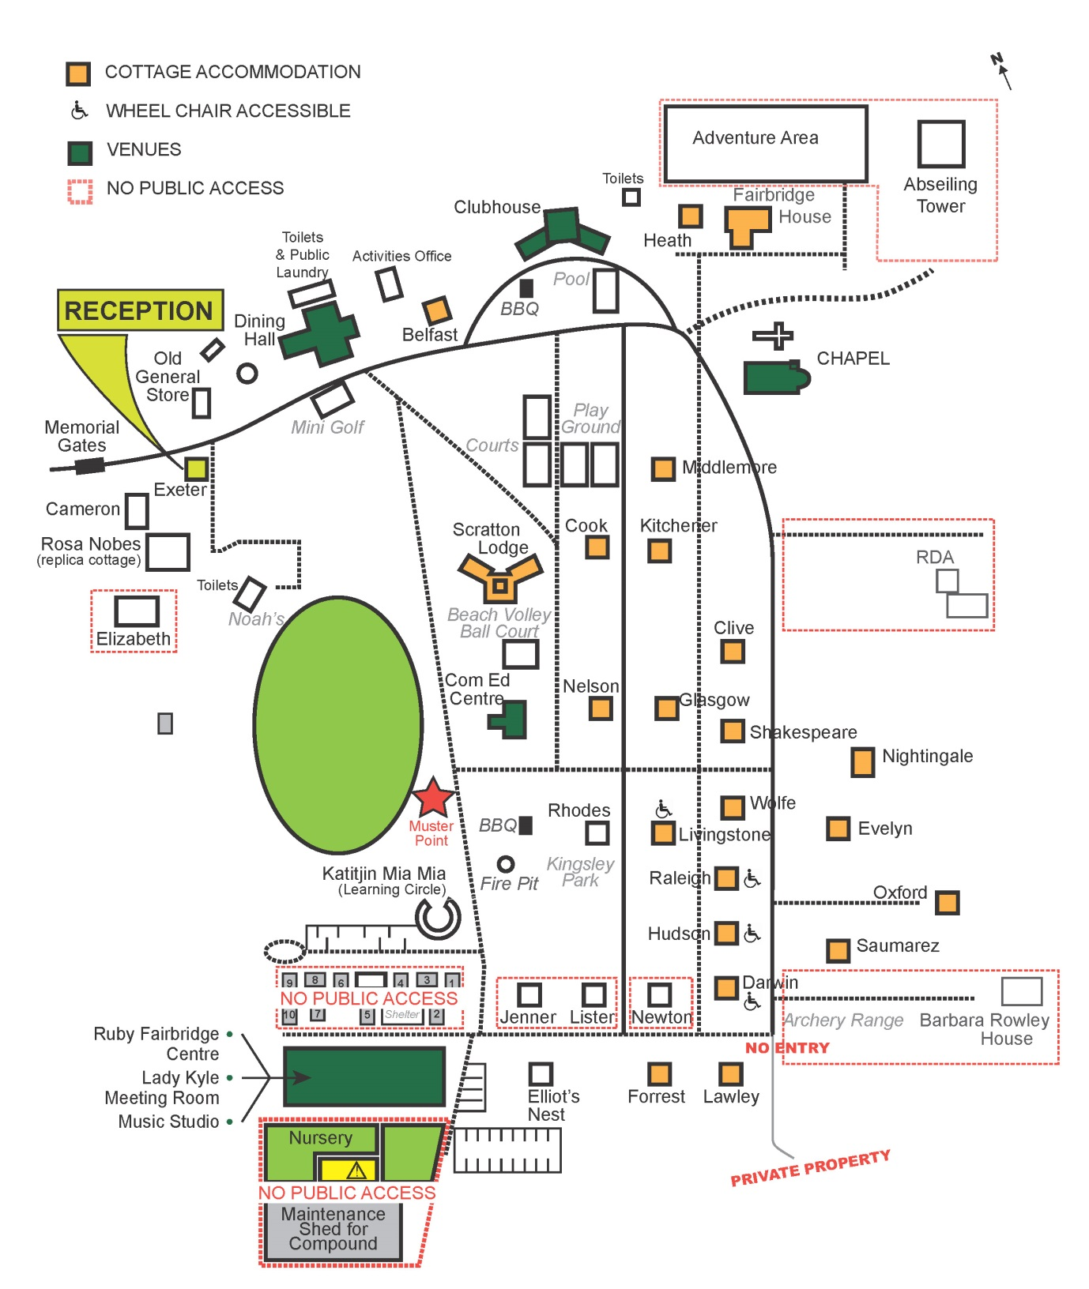

Autographs

